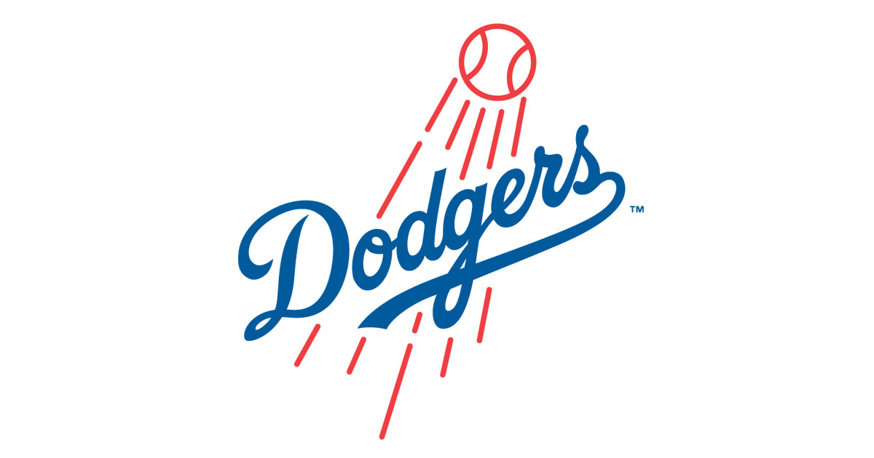
Please join us in attending
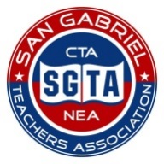
San Gabriel Teachers’ Association
Night with the Dodgers!

It’s time for Dodger Baseball!
Bring out the family and friends for a fun night of baseball and fireworks at Dodger Stadium.
The Dodgers will be taking on the Chicago Cubs.
Friday, August 26th , 7:10 p.m.
Dodger Stadium, Los Angeles
Open to all families and friends of SGTA
$20.00 per ticket
Fireworks Show Immediately Following the Game!
Please order your tickets today! Seating is limited!
Seating is for Infield Reserve Section 35RS.
We are locked in at the purchase price of $20.00.
Admission for parking is on your own.

Make checks payable to San Gabriel Teachers Association and send them to Vicki Mireles at Mckinley. You will receive a receipt in the mail and the tickets will be disbursed By Personal Email in the Fall 2016.
Name: _____________________________ School Site: ______________________________
Quantity of Tickets: __________ x $20.00 Total Amount $ __________________________
Personal Email: ________________________________________________________________
(*Necessary to receive an email copy of the tickets)

